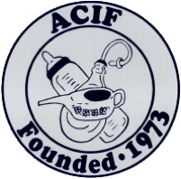

Convention & Annual Dues Form
2023 ACIF CONVENTION
October 12 - 14, 2023
Augusta County, Virginia

Hotel---- Residence Inn Waynesboro
44 Windigrove Drive
Waynesboro, VA
Phone Number: 540-943-7426
When making reservations reference “American Collectors of Infant Feeders”
Room rate
- $189 (plus tax) Wednesday October 11 through checkout Sunday October 15
- Rooms are Studios with King and Sofa beds and a kitchenette
Breakfast included with room price
Please make your reservations by September 15, 2023 to receive the above rates

Convention days this year will be:
- Thursday October 12 – welcome and dinner together
- Friday October 13 – group sightseeing & antiquing, evening program and Fun Fund Auction
- Saturday October 14 – Antique Expo, lunch at Jody Woodward’s and see her collections, evening program and Sale
Please indicate who will be attending the 2023 Augusta County, Virginia Convention.
1__________________________________________________________
2__________________________________________________________
Are you bringing items for the Fun Fund Auction? Tables needed ½_____Full____
Indicate number of tables needed for Saturday night’s sale ½______Full_____
ACIF DUES FOR July 2023 -June 2024 are $40.00
Make checks payable to ACIF (and provide member name(s) and contact information)
MAIL TO: CHARNA SANSBURY, Treasurer
30 White Birch Court, Gibsonville, N.C. 27249

